RESEARCH OF THE APPLICABILITY OF POLYNOMIAL AND COSINE DECOMPOSITION FOR APPROXIMATING POWER CONSUMPTION OF A MOBILE ROBOT MOTION ON DIFFERENT tERRAIN TYPES

Kushnarev O. 1, Belyaev A. 2

1 TPU, SCSR, Gr. 8EM31, e-mail: [okushnarev@tpu.ru](mailto:%20okushnarev@tpu.ru)

2 TPU, SCSR, PhD Tech., Senior Lecturer, e-mail: [asb22@tpu.ru](mailto:asb22@tpu.ru)

**Abstract**

This paper studies the approximation of energy costs for mobile robot motion. Obtained patterns could serve as terrain characteristics and be used to distinguish different terrains. It is shown that the cosine decomposition has a better approximation accuracy with lower model complexity as compared to the polynomial decomposition.

**Keywords:** mobile robot, energy consumption, terrain characteristics, polynomial decomposition, discrete cosine transform.

**Introduction**

Energy losses during the motion of mobile robots represent an important part of research in outdoor mobile robotics. Since these robots move in environments that have different effects on the robot's propulsion system. Therefore, information about the characteristics and type of terrain must be considered in the navigation system to ensure a high quality of motion. In this regard, the power consumption of motion on the terrain can be a parameter describing the terrain characteristics on the one hand and an input for the robot control system on the other hand.

The consumed power is used to determine the energy loss of robot motion in [1]. The authors use a method to analyze the consumed power and estimate the friction coefficients on different terrains. For this purpose, a mathematical model is presented that estimates sliding friction as a function of sliding angles and radius of curvature of the motion path. Experimental measurements were conducted on various types of terrain such as marble, wood, concrete, and soil. By analyzing the power consumption and estimating the friction coefficients, the authors evaluate the effect of different types of terrains on the robot's performance and energy efficiency. According to the authors, the resulting terrain characteristics can be integrated into the robot's motion planning to optimize its performance on different terrains.

Predicting the energy consumption of a robot while traversing various terrains is crucial for effective path planning. This is clearly demonstrated in [2]. The authors consider the influence of various terrain types, including concrete roads, grass, sand, and others, on the energy consumption of mobile robot motion.   
The paper evaluates the energy consumption of movement on different terrains and at different robot speeds. The terrain energy consumption ratio is calculated by comparing the power required to traverse the current terrain to the power required to traverse a flat, smooth baseline terrain. This ratio is then utilized to identify the most energy-efficient path for mobile robots through a weighted graph.

Other methods are also used to characterize terrains. For example, in [3], the authors obtain terrain information using motor current and rate of turn of the mobile robot. This data is collected while the robot is moving over different types of terrains such as gravel, grass, dirt, sand, and asphalt. By analyzing the relationship between motor current and turning speed on different terrains, the authors produce characteristic curves that represent the robot's behavior on each type of terrain. These curves allow further classification of terrains and evaluation of their traversability for mobile robots. In [4], terrain information is obtained using the vibration and torque data of the robot's hybrid wheel-leg propulsors. The torque, meanwhile, is estimated using current sensors mounted on the robot's motors. This data enables the estimation of slippage and physical terrain properties, such as stiffness and coefficient of internal friction. The authors also suggest the possibility of using the real-time characteristics obtained to evaluate the level of ground hazard.

Based on the works presented above, we conclude that the use of information about energy losses or power consumption can allow solving various problems of mobile robots moving on different terrains.   
The use of these characteristics in [2] is limited only by the type of invariant coefficients, and do not take into account the influence of other variable motion parameters. That is why this paper considers the problem of investigating the possibility of using existing approximation methods, such as polynomial decomposition and discrete cosine transform, to approximate the energy costs of robot motion over different types of underlying terrains.

**Experimental setup**

Fig. 1 shows a schematic of the experimental setup using a Festo Robotino 1.6 mobile robot as in [5]. The robot's movements are determined by the velocities in its local coordinate system. The robot runs on three DC motors, which are equipped with current and voltage sensors. During the experiments, the robot moves around an experimental site with various types of underlying terrain: type 1 – gray terrain, soft and smooth; type 2 – green terrain, hard and rough; type 3 – table, hard and smooth. Each of these terrains affects the robot's movement in a different way.

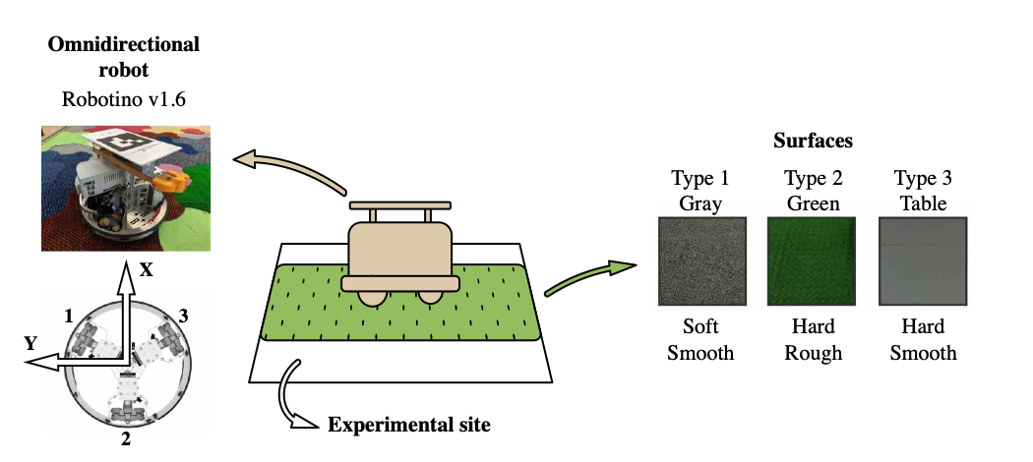

*Fig. 1. Schematic representation of the experimental setup*

The power consumed is calculated using the formula:



where *Ui* is thesupply voltage of the *i-th* motor, *Ii* is the current consumption of the *i-th* motor, *N* is the number of motors.

During experiments power consumption data is collected from the mobile robot moving on all three types of terrains: gray, green, and table. For each type of terrain, the data is obtained for motion directions from 0 to 355 degrees with a 5 degrees step. The amplitude varies from 0.1 to 0.3 m/s. The obtained data are shown in fig. 2. It displays the median values and the values of the first and third quartiles for each type of terrain.

We use polynomial and cosine series decomposition to approximate the obtained data. The cosine decomposition was selected due to the clear similarity of the obtained data with harmonic functions, as shown in the example of gray and green terrains in fig. 2.

**Analysis**

For the sake of clarity, the analysis approach is illustrated using the example of a gray terrain.   
To estimate the upper limit of the acceptable approximation error for a particular direction, the average relative deviation from the median of the values of the first and third quartiles of the sample is calculated. In the case of a gray terrain, the distance from the median to the first quartile is 3.42 % and to the third quartile is 3.58 %. These values define the interval within which we expect the approximation of the data to be representative. Since the values are close to each other, it is assumed that the error in predicting the median values should be below the mean of the two outliers, i.e. less than 3.5 %.

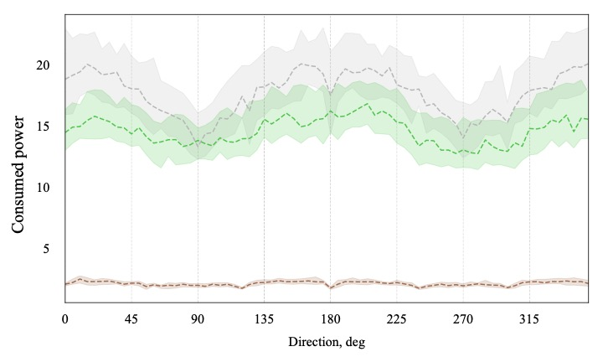

*Fig. 2. Value of median, first and third quartiles for all directions of motion and terrains  
(gray and green terrains correspond to colors on the graph, brown for the table)*

The goal of polynomial approximation is to find a polynomial of a specific degree that provides the best possible approximation of a given data set. This is accomplished through the use of the least squares method, which minimizes the sum of squares of the differences between the actual function values and the polynomial values.

The Discrete Cosine Transform (DCT) allows to represent a signal as a sum of cosine functions of different frequencies and amplitudes. The cosine transform has some advantages over the Fourier transform. DCT represents the signal more compactly, since the main information is contained in the first components, and therefore fewer coefficients will be needed to describe the dependencies. DCT requires fewer computational resources and has a simpler structure. This is because cosine transform uses only real coefficients, while the Fourier transform requires complex numbers, which increases memory space and computational complexity.

Model complexities are rated for comparison purposes. The degree of the polynomial is used to rate polynomial functions, while the number of coefficients is used to rate cosine transformations. In this case, the number of cosines in the function will be one less than the number of coefficients. This is because the   
y-intercept is included in the coefficients. Figure 3 shows a comparison of the errors of the models for the gray terrain.



*Fig. 3. Errors of models approximating median gray terrain values versus model complexity*

The graph shows that the cosine decomposition provides higher accuracy of approximation compared to the polynomial one with equal model complexity. Also, the model error becomes less than 3.5 % only when a sixth-degree polynomial is used. The cosine model may achieve better quality at lower complexity due to its more efficient extraction of basic dependencies from the data, thanks to the initial similarity of the graph of medians with the harmonic function. The polynomial model reaches a plateau in accuracy as its complexity increases, while the cosine model continues to improve accuracy. It should be noted that this conclusion is based on the limited complexity of the cosine decomposition. It is logical to assume that the approximation with cosine series also asymptotically tends to a fixed value of the error.

The same analysis is applied to the green terrain and the table. Figures 4 and 5 show the results of approximation by polynomial and cosine models of minimum acceptable complexity, i. e. with average percentage error less than 3.5%.

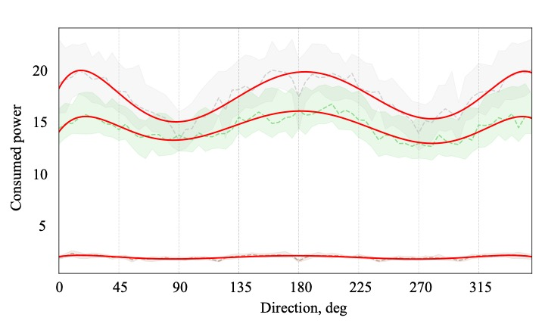

*Fig. 4. Polynomial approximation of median values of the power input by a polynomial of the sixth degree*

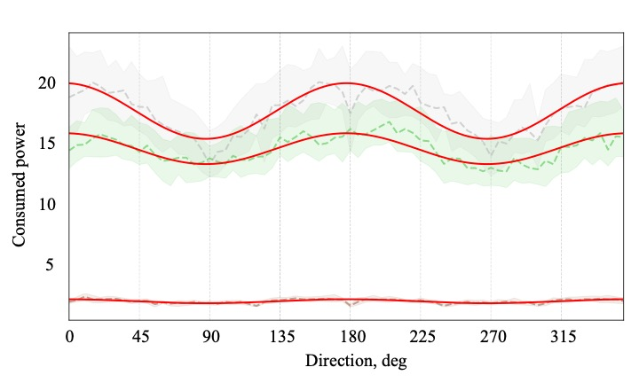

*Fig. 5. Approximation of median values of the power consumption by cosine decomposition with two coefficients*

**Conclusion**

Both models, cosine decomposition and polynomial approximation, accurately describe the relationship between the change in median power input and the direction of motion of the mobile robot. However, in this particular problem, the cosine decomposition model is more accurate than the polynomial approximation model, despite having a lower level of complexity. Extra advantage of cosine decomposition is that it is not affected by the Runge phenomenon, which can cause significant errors in approximation when using polynomial functions.

It is worth saying that the approximated functions can be applied to terrain classification problem. Deriving these dependencies enables a transition from a discrete set of studied robot motion directions to a continuous function. This allows for interpolation of power consumption median values for any direction of robot motion. Therefore, considering that the approximated functions of consumed power for different terrains are placed in distinct parts of value’s range, they can be used to distinguish between terrains.

**References**

1. Dogru S, Marques L. Power Characterization of a Skid-Steered Mobile Field Robot. In: Proceedings - 2016 International Conference on Autonomous Robot Systems and Competitions, ICARSC 2016. – 2016.
2. Yuan Q, Lu Q, Xi Z. Optimal path selection for mobile robots based on energy consumption assessment of different terrain surface. In: Chinese Control Conference, CCC. – 2017.
3. Ojeda L, Borenstein J, Witus G. Terrain trafficability characterization with a mobile robot. In: Unmanned Ground Vehicle Technology VII. – 2005.
4. Comin FJ, Saaj CM. Models for slip estimation and soft terrain characterization with multilegged wheel-legs. IEEE Transactions on Robotics. – 2017. – 33(6).
5. Belyaev A.S., Kushnarev O. Yu., Brylev O.A. Synthesis of a hybrid underlying surface classifier based on fuzzy logic using current consumption of mobile robot motion. Informatsionno-upravliaiushchie sistemy [Information and Control Systems]. – 2024. – no. 1. – pp. 31-43.